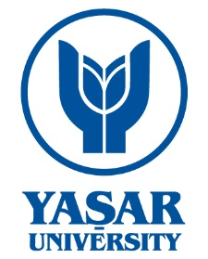
EUROPEAN UNION RESEARCH CENTER

WORKING PAPER

TITLE OF THE PAPER
Authors’ Names

EUC - WP (4)- October 2012
ISBN 978-94-6138-231-7

© 2012. All rights reserved. No part of this paper may be distributed, quoted or reproduced in any form without permission of Yaşar University European Union Center. The views expressed in this paper are those of the authors and do not necessarily represent any institution with which they are affiliated.

Title :

Abstract (Max.250 words) :

Keywords :

Authors’ Information (Affiliations)

Contact :

Authors’s Name I Year

YAŞAR UNIVERSITY EUROPEAN UNION CENTER

Founded in Izmir in 2005, Yaşar University, European Union Research Center functions to stimulate and strengthen the participation of Yaşar University in the EU Research and Education Programmes, and monitors the developments in this field.

The Center aims to;
- develop and participate in new EU projects under different EU grant schemes,
- support academic studies and researches on EU issues,
- organize seminars, trainings and certificate programmes,
- support the mobilization of students and academics for exchange of knowledge with various EU higher education institutions and research centers.

It also takes part in joint projects by participating in different European networks and consortium and establishes new exchange and cooperation agreements. Currently, the Center runs several EU projects including short-term intensive courses, training programmes, mobility of researchers and e-learning programmes. It also offers project cycle management trainings for students, academics, public authorities and NGOs.

The Center supports all Yaşar faculties, departments, and vocational school programmes in terms of functioning as the consulting body for Yaşar students and academics in the framework of developing EU projects with international, local institutions and organizations.

The Working Paper series provides a platform for work in progress which seeks to draw comments and stimulate further discussion. The series includes academic research by staff, graduate students, post-doc researchers and visiting fellows.

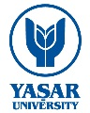

Yaşar University
European Union Research Center
Universite Cad. No:35-37 35100 Bornova Izmir/TURKEY
Tel: +90 232 411 50 14 Fax: +90 232 411 50 22
Web: http://euc.yasar.edu.tr E-Mail: euc@yasar.edu.tr

http://euc.yasar.edu.tr

